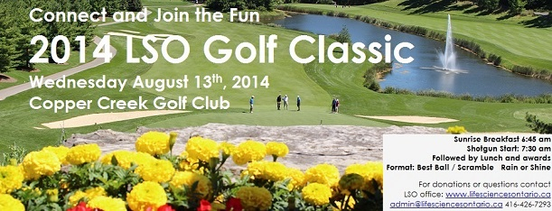

2014 LSO Annual Golf Classic
Wednesday, August 13th, 2014
Copper Creek Golf Club

Registration at 6:30am
Shotgun Start at 7:30am
Lunch and awards in the clubhouse following the round
Format: Best Ball / Scramble
**Rain or Shine

Register Early for exciting - Early bird Prizes
Register and pay for a foursome by June 27th and be entered into a draw for 1 of 2 rounds of golf for 2 at Copper Creek Golf Club and 1 complementary registration to the 2014 LSO Fall Event

Member
*Foursome: $1,500 (includes hole sponsor) +HST
*Individual: $300 +HST
Non Member
*Foursome: $1,600 (includes hole sponsor) +HST
*Individual: $325 +HST
Click here to register online
Click here to download a registration form

Attention Non-Golfers
If you are not a golfer, join us for the networking reception and luncheon.
To register online, click here
Networking Lunch only: $40 +HST
Attention Organizations
Are you a non-golfer, and can't attend the networking lunch and are looking to reach the Life Sciences Sector. We are currently looking for prizes for:
Golfer goodie bag: (past examples: sunscreen, mints, USBs, hand sanitizers)
Prize table (past examples: golf supplies - bags, towels, balls, clubs, shirts)
Silent Auction table (past examples: tickets (sport events, conferences, galas), gift baskets)
All donors are recognized onsite in the program book, as well as on the screens and thanked by the Golf Committee Chair during his remarks.
Donors will also be listed on LSO website.
Silent Auction
Again this year, all proceeds raised from the Silent Auction will go towards:
Partners in Research
in support of
If you have any item that you would like to donate, please contact the office for more details.

Life Sciences Ontario
1 Concorde Gate, Suite 109, Box 26
Toronto, ON, M3C 3N6
admin@lifesciencesontario.ca
Tel.: 416 426-7293

